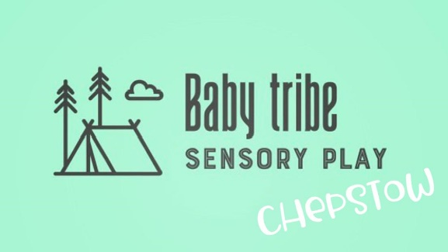

**Terms and Conditions**

**Disclaimer**

Baby Tribe’s Terms and Conditions aim to present a fair and sustainable structure to all. We are committed to the safety of all session attendees and to delivering the highest quality experience. Please be aware that the use of feathers and other animal products may be used in sessions. We will endeavour, where possible, to provide an alternative activity should you require. Participating in a Baby Tribe sensory session is entirely at your own risk without any proven negligence, breach of duty of care or lack of due diligence.

**Terms and Conditions**

**Cancellations**  
Baby Tribe Sensory is committed to running scheduled sessions in all but exceptional circumstances. If a session must be cancelled for reasons beyond our control (e.g. fire, flood, extreme weather or sickness), we will make you aware as early as possible. We regret that we are unable to offer refunding or rescheduling of sessions in the event of adverse conditions local to yourselves that prevent you from attending a booked session.

**Bookings**  
The booking fee is to secure your child’s space in the group for a specified session and we are unable to offer refunds should you not manage to make it or change your mind without 48 hours’ notice provided.

**Health and Safety**  
The health and safety of the babies and parents/carers attending Baby Tribe sessions is paramount and full public liability insurance is in place.   
Please not that it is your responsibility to inform your group facilitator if you or your child suffers from a medical condition which they should be aware of. This information may be recorded, however will be kept confidential other than in the event of a medical emergency, in which case it would be shared with healthcare professionals. Examples include epilepsy (as sensory equipment with flashing lights is used) and allergies.  
Every effort will be made by Baby Tribe to provide a safe and hazard-free zone, however, parents are responsible for the safety and wellbeing of their child. Please ask your group facilitator if you have any concerns about any activities and safety information will be provided where necessary.  
All activities are optional and if at any time you do not wish for your child to take part in a particular activity or element of the session then just let your group facilitator know.  
Baby Tribe activities are to be undertaken under constant supervision by parents/caregivers at all times. In the unfortunate event of an accident, please report this to your group facilitator as soon as possible, who will where relevant, contact the emergency services and work with them where possible. Please report even apparently minor accidents to your group facilitator so they can assist you in filling out the necessary paperwork.  
All equipment is carefully checked before and after each use. Should you find anything unsatisfactory, please make your group facilitator aware of this immediately.  
Baby Tribe cannot accept any responsibility for the loss or damage of any personal possessions.

**Illness**  
Parents are requested to refrain from attending Baby Tribe sessions if they or thir baby has a serious infection.  
Please keep your baby at home if he/she has:

* A fever or has had one in the previous 48 hours.
* Had an upset stomach or diarrhoea in the previous 48 hours.
* Sticky or discharging eyes.
* A heavy runny nose.

Or has symptoms of a possible contagious disease, for example:

* Chicken pox
* Norovirus
* Whooping cough
* Measles
* Mumps
* German measles
* Scarlett fever
* Impetigo
* Hand, foot and mouth disease

Please wait until your doctor has given the all clear before returning to Baby Tribe.

**Covid-19**  
Despite the government removal of all Covid restrictions, if you suspect you or your baby have Covid-19, we would kindly ask that you do not attend the session until you believe you are no longer infected. We have lots of small, vulnerable babies that attend the session and we do not want to put them at risk.

**Photographs and Marketing**  
Baby Tribe allows parents to photograph their own baby/babies during sessions. Whilst we ask parents to ensure they only photograph their own baby/babies, occasionally your child may be photographed in the background.  
Baby Tribe will occasionally photograph/video for promotional purposes i.e. for use on Baby Tribe Sensory website/Instagram account. Please make your group facilitator aware if you do not wish for your baby to feature in any promotional photos or videos.

**Confirmation**  
Please note that once you have booked your place and paid the fee indicated to secure the booking, fees are non-returnable and non-transferable. You will receive an email confirmation once your baby’s booking has been confirmed.  
Before your first session, you will be required to read and agree to Baby Tribe Sensory’s Terms and Conditions.

**Withdrawal of Service**  
Baby Tribe may at its own discretion refuse entry to a client if it is felt that the client’s behaviour or presence may compromise the wellbeing or safety of session attendees.

**Complaints**  
Yours and your baby’s enjoyment is of upmost importance to us and we really hope you love our classes. In the event that you are unhappy with any aspect of Baby Tribe please do let us know by emailing info@babytribe.net